**How to build and excute the on-site SEO for website**

Page Title: Bakers corner Bakery

Header: Homemade Delights:

1. Bakers corner -Fresh Baked Goodness in Namakkal

Meta discription: “Explore our mouthwatering treats today!” encourage s action and sets the expectation of delicious products.

Primary keyword:

* Bakers corner bakery
* Bakery in namakkal
* Cakes and Brownies
* Customizing cakes

Secondary keyword:

* Custom birthday cake designs
* Homemade bread and roll near me.
* Eggless and dairy free pastries
* Fresh baked goods for corporate events

Image Alt-text

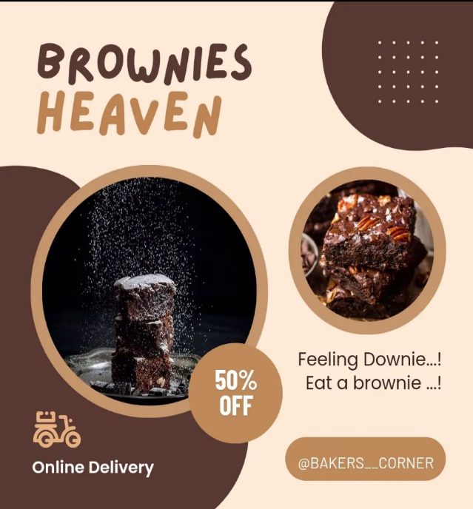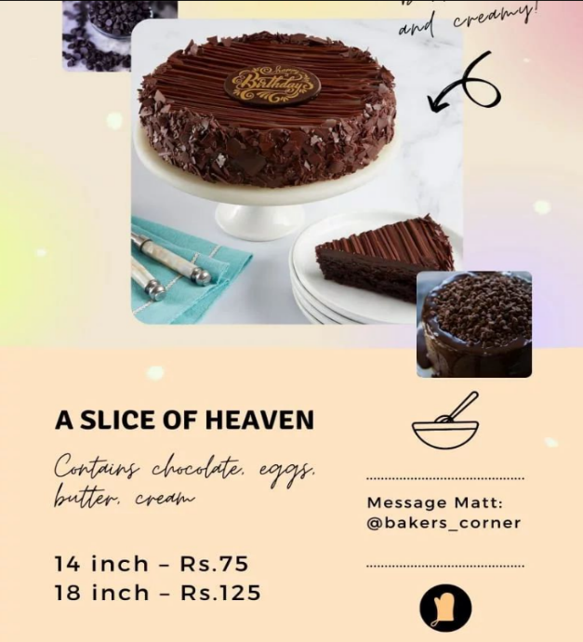

Page url: https://www.blogger.com/blog/posts/7955796827999469447

Interal linking: This link one to another within the website.

Mobile Responsiveness: To increase and easily accessable over a mobile itself.

Speed site:It determines the speed of our website(loading,internal linking,External linking)

Structural markup: Structural markup, is a way to provide search engine with additional information about our bakery shops content.this can help search engines understand our website better and potentially display rich snippets in search result.

External linking: It can help improve our website‘s authority and ranking in search engine results(social media advertising)

Content:

**Title:**

*Discover Sweet Delights at Bakers Corner Bakery - Your Go-To Bakery in Namakkal*

**Introduction:**

When it comes to satisfying your sweet cravings in Namakkal, Bakers Corner Bakery is the name to remember. Our bakery is a haven for cake and brownie enthusiasts, offering an array of delectable treats that will tantalize your taste buds. From crafting custom birthday cake designs to serving up eggless and dairy-free pastries, we're your one-stop shop for all things sweet. In this article, we'll delve into our specialties, including our cakes and brownies, and how we can make your special occasions even sweeter with our custom offerings.

**Cakes and Brownies:**

At Bakers Corner Bakery, we take pride in our mastery of the art of baking. Our cakes are a symphony of flavors, designed to add that extra sweetness to your life. Whether you're celebrating a birthday, anniversary, or any other special event, our custom birthday cake designs are the perfect way to make the day unforgettable.

Our expert bakers pay meticulous attention to detail, ensuring that each cake is a masterpiece. We offer a wide range of flavors, from classic favorites like rich chocolate and velvety vanilla to unique and exotic creations that will leave your guests in awe. And if you're looking for something more casual, our brownies are a delightful option for a quick sweet fix.

**Customizing Cakes:**

What sets Bakers Corner Bakery apart is our ability to create cakes that are as unique as you are. Our custom birthday cake designs are tailored to your preferences, making your celebrations truly one-of-a-kind. Whether you have a specific theme in mind, dietary restrictions, or a special flavor combination, we can turn your vision into a delicious reality.

Our expert cake decorators use their creativity and skill to craft cakes that not only look amazing but also taste divine. Just share your ideas with us, and we'll bring your dream cake to life.

**Homemade Bread and Rolls Near Me:**

But our bakery is not just about sweet treats; we also offer a selection of homemade bread and rolls. If you're searching for "homemade bread and rolls near me," you've found the right place. Our bread is baked with love and care, using the finest ingredients, resulting in the perfect balance of softness and flavor. From classic white bread to whole-grain options, our bakery has something for every palate.

**Eggless and Dairy-Free Pastries:**

At Bakers Corner Bakery, we understand that dietary preferences and restrictions vary. That's why we're proud to offer a selection of eggless and dairy-free pastries. Our skilled bakers have perfected the art of creating pastries that are just as scrumptious as their traditional counterparts but suitable for a variety of diets. Indulge in the joy of our pastries, guilt-free.

**Fresh Baked Goods for Corporate Events:**

If you're planning a corporate event or a meeting, impress your colleagues and clients with our fresh baked goods. Our bakery provides a range of options, including pastries, cakes, and rolls, that will elevate your event. We offer convenient catering solutions, ensuring that your guests are treated to the finest baked goods in Namakkal.

**Conclusion:**

Bakers Corner Bakery is not just a bakery; it's a place where we turn every occasion into a sweet and memorable experience. Whether you're in search of custom birthday cake designs, homemade bread, eggless and dairy-free pastries, or fresh baked goods for corporate events, we have you covered. Visit us in Namakkal and let us delight your senses with our delectable offerings. Your sweet journey begins here at Bakers Corner Bakery!